Tribal Climate Tool Colloquium
CONN 350 Modeling Earth’s Climate

Primary Learning Goal
- Foster a venue for more in-depth discussion at the intersection of climate change and climate justice, particularly concerning knowledge, identity, and power.
Instructions
In class on Monday and Wednesday
- Choose a Pacific Northwest Tribe from Oregon State University’s Tribes of the Pacific Northwest Region. Indicate your selection on this Google Sheet.
- Use the tribes website (linked on OSU’s page) and additional online resources to explore the tribe’s history, culture, and connection to nature. Use the Tribal Climate Tool to see how climate variables are expected to change on the tribe’s land. This document provides space to record insights.
- Create a 1-page handout with hand-drawn visuals that symbolize the most essential points of your findings and discussion. Take this in any direction your group wants. For example, the visual could use a metaphor or be created in the style of a community mural, a tattoo sleeve, a map, or a music album cover.
In class on Friday
- You will present your 1-pager and synopsis of your group discussion to other small groups of students. You will also facilitate a discussion.
- Your team will record the evolution of the discussion on chart paper.
- Each group will present twice and be presented to twice, then we will debrief as a whole group.
Grading
Group Presentation and discussion leadership - 15 Points
- The visual one-pager is appealing and provides enough information to spark further conversation (5 points).
- Questions and important points drawn from research using the Tribal Climate Tool and tribe websites are engaging, relevant, and interesting (5 pts)
- Presentation and discussion are well conveyed and discussed during the colloquium (5 pts)
Participant in discussion - 5 Points
- The student was engaged and able to actively contribute to the discussion during both conversations (5 pts)

Example One Pagers
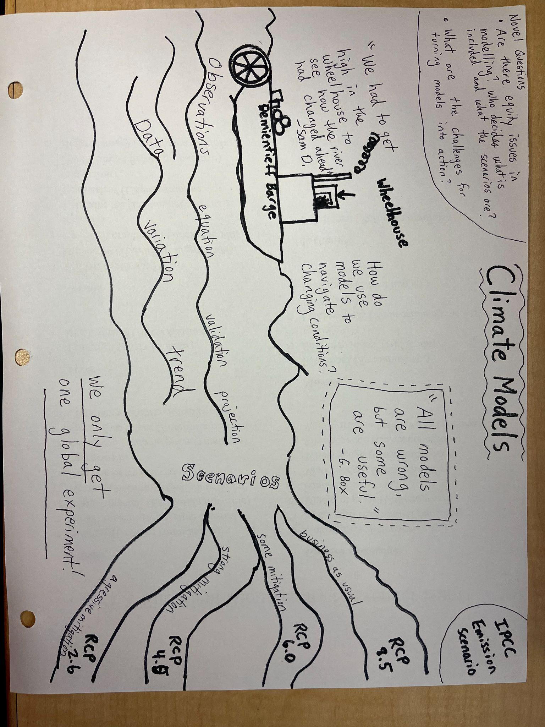
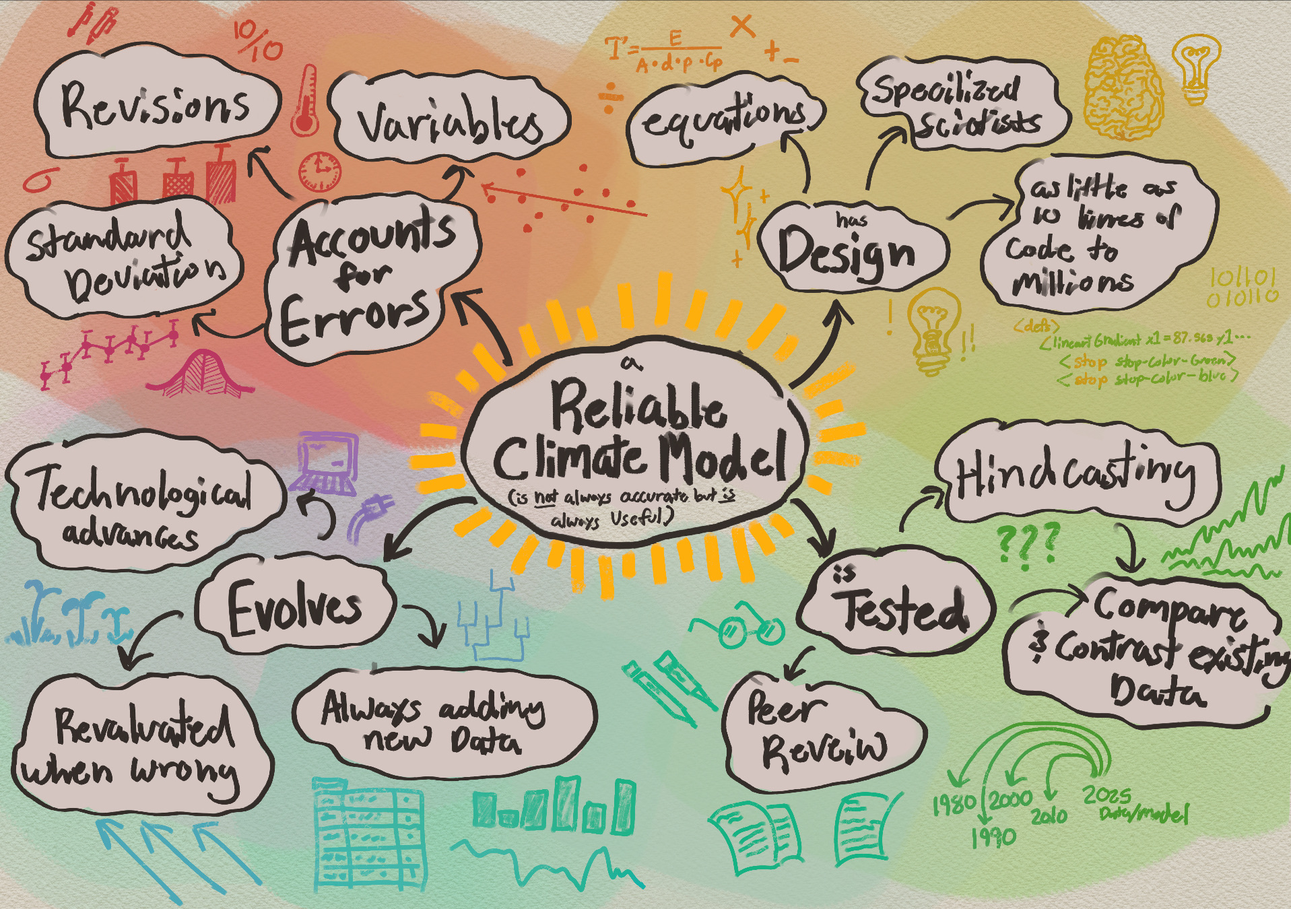

Chosen Pacific Northwest Tribe

Insights from Tribal Website research (and other resources):

Insights from Tribal Climate Tool (especially resources/variables important to Tribe):

Intersections between research and the Tribal Climate Tool insights:
Colloquium discussion prompts and questions:

Colloquium Visual Planning:

